**Creating a React Application “myfirstreact”**

create-react-app myfirstreact

**Navigate to location**

cd myfirstreact

**Modify App**

function App() {

return (

<div>

<h1>Welcome to the first session of React</h1>

</div>

);

}

export default App;

**View in Browser**

<http://localhost:3000>

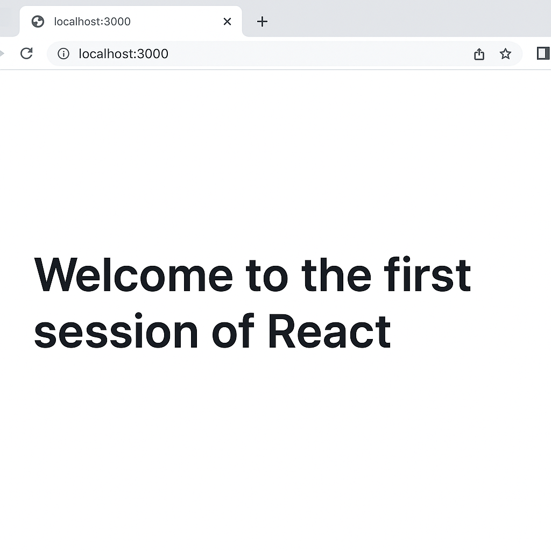

**Create React Project**

npx create-react-app StudentApp

**Navigate to Project Folder**

cd StudentApp

**Create Components Folder**

Inside **src** folder:

Create a new folder named **Components**.

Inside **Components**, create three files:

**Home.js**

**About.js**

**Contact.js**

**Create Home.js**

import React from 'react';

function Home() {

return (

<div>

<h1>Welcome to the Home page of Student Management Portal</h1>

</div>

);

}

export default Home;

**About**

import React from 'react';

function About() {

return (

<div>

<h1>Welcome to the About page of the Student Management Portal</h1>

</div>

);

}

export default About;

**Contact**

import React from 'react';

function Contact() {

return (

<div>

<h1>Welcome to the Contact page of the Student Management Portal</h1>

</div>

);

}

export default Contact;

**#3**

**Create React Project and create component folders**

**Code for Calculate Score.js**

import React, { useState } from 'react';

import '../Stylesheets/mystyle.css';

function CalculateScore() {

const [name, setName] = useState('');

const [school, setSchool] = useState('');

const [total, setTotal] = useState('');

const [goal, setGoal] = useState('');

const [average, setAverage] = useState(null);

const handleCalculate = () => {

if (total && goal) {

const avg = (parseFloat(total) / parseFloat(goal)).toFixed(2);

setAverage(avg);

}

};

return (

<div className="container">

<h2>Student Score Calculator</h2>

<input

type="text"

placeholder="Enter Name"

value={name}

onChange={(e) => setName(e.target.value)}

/><br />

<input

type="text"

placeholder="Enter School"

value={school}

onChange={(e) => setSchool(e.target.value)}

/><br />

<input

type="number"

placeholder="Enter Total Score"

value={total}

onChange={(e) => setTotal(e.target.value)}

/><br />

<input

type="number"

placeholder="Enter Goal Score"

value={goal}

onChange={(e) => setGoal(e.target.value)}

/><br />

<button onClick={handleCalculate}>Calculate Average</button>

{average && (

<h3>

{name} from {school} has an average score of {average}

</h3>

)}

</div>

);

}

export default CalculateScore;

**CSS**

.container {

width: 400px;

margin: 50px auto;

padding: 20px;

border: 2px solid #333;

border-radius: 10px;

text-align: center;

background-color: #f5f5f5;

}

input {

width: 90%;

padding: 8px;

margin: 10px 0;

border: 1px solid #ccc;

border-radius: 5px;

}

button {

padding: 10px 20px;

background-color: #007bff;

color: white;

border: none;

border-radius: 5px;

cursor: pointer;

}

button:hover {

background-color: #0056b3;

}

h2 {

color: #333;

}



**Create Post.js**

import React from 'react';

class Post extends React.Component {

render() {

return (

<div className="post">

<h2>{this.props.title}</h2>

<p>{this.props.body}</p>

</div>

);

}

}

export default Post;

**Create Posts.js**

import React from 'react';

import Post from './Post';

class Posts extends React.Component {

constructor(props) {

super(props);

this.state = {

posts: [],

error: null

};

}

// Step 6: Method to load posts

loadPosts = () => {

fetch('https://jsonplaceholder.typicode.com/posts')

.then(response => response.json())

.then(data => {

this.setState({ posts: data });

})

.catch(error => {

this.setState({ error });

});

};

// Step 7: Call loadPosts inside componentDidMount

componentDidMount() {

this.loadPosts();

}

// Step 9: Handle errors

componentDidCatch(error, info) {

alert("An error occurred: " + error);

}

// Step 8: Render posts

render() {

const { posts, error } = this.state;

if (error) {

return <h3>Error loading posts</h3>;

}

return (

<div>

<h1>Blog Posts</h1>

{posts.length === 0 ? (

<p>Loading posts...</p>

) : (

posts.map(post => (

<Post key={post.id} title={post.title} body={post.body} />

))

)}

</div>

);

}

}

export default Posts;